CS 340 README Project Two

About the Project/Project Title
Grazioso Salvare Animal Sorting application. Animal Shelter Database. This application displays a list of animal information, divided in pages with 20 items per page, combined with filter options for dogs that could fit a type of rescue efforts.

Motivation
Grazioso Salvare wishes to be able to accurately find dogs that can help in rescue efforts and have paired up with the Austin Animal Center to find dogs that fit the mold. They desired for an application that filters through the list of animals held in the Austin Animal Center to train for the aforementioned rescue efforts. That is where this application comes in, not only does it filter animals that fit their specifications, but it shows where in Austin these animals are, either being sheltered or fostered. For tool utilization, MongoDB combined with a Python based interface, was best determined for this utilization due to the ease of database interacting and the integration with Python to be able to find data easily. For Front end operation, Dash was utilized due to it’s Python based Framework that allow for seamless web based applications and web controlling, making it easier to design and implement features that assist in the filtering process and the database displaying process along with widgets and graphs that support the data being displayed (including the Map feature that heavily supports the dog finding process)

Getting Started
To utilize the Dash based application you will need to be able to utilize a Python Compiler with internet connectivity as the application is ran on an open internet port. You will also need to have access to MongoDB, the URL will be provided in the Installation section. PyMongo is a required linking tool for Pythong to be able to interact with MongoDB and the databases within, along with Plot.ly for all graphing needs within Python.

Installation
PyMongo is necessary tool and can be installed in a command-line interface utilizing “pip install pymongo”. A normal command-line interface is necessary as well and comes packaged in all OS systems
Plot.ly can be downloaded a similar way with ”pip install plotly” on any command line terminal
Dash is a same way but with Dash in the pip.
All aforementioned items need to be included into your python script if you wish to make your own front end application to interact with MongoDB
MongoDB is the database base system that all databases utilized here are stored and can be utilized with a free download provided by MongoDB at this website: https://www.mongodb.com/try/download/community-kubernetes-operator

Steps Of Completion:
- Import python module with database interacting code with CRUD implementation to support database interactions
- Initialize the python object for dash utilization of database querying, along with logging into database through initialization call
- Create dataframe and pass all documents to form base of dataframe
- Create dashboard layout for base formulation and to provide a screen for dataframe showcasing
- Create filtering menu and populate the menu with the company’s filtering desires
- Create and implement controller and interacting components:
  - Implement update functionality for the database querying, graph formulating and map updating
    - Create filtering method that queries whenever 1 of the dropdown menu options is selected. This is based on 3 types of aid rescuing that dogs can support.
    - Create graphing ability that takes in the data currently displayed, and accounting for filtering of documents. In this case was a pie chart for breeds
    - Create map display ability that takes in the database document currently selected and showcases the animal’s lat/long data on a digital map
- Ensure proper syntax, and error correcting and finally run the server.
- Troubleshoot any errors showcased during the testing process and ensure data is displayed properly. Correct errors and repeat.

Usage

Screenshots
Base: 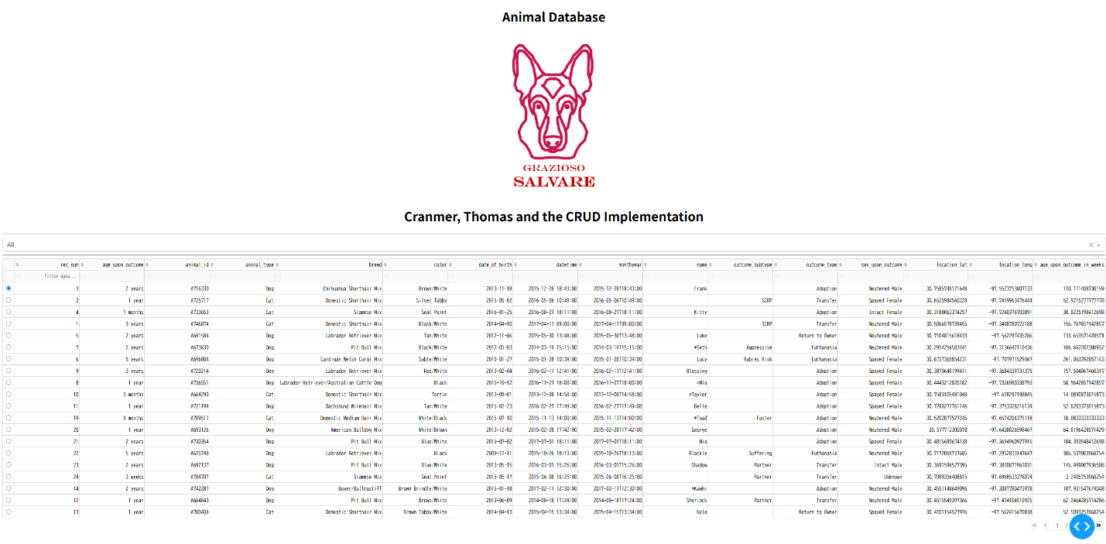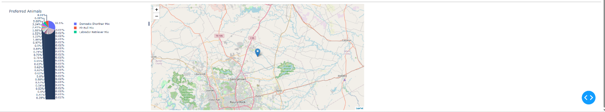
Water Rescue: 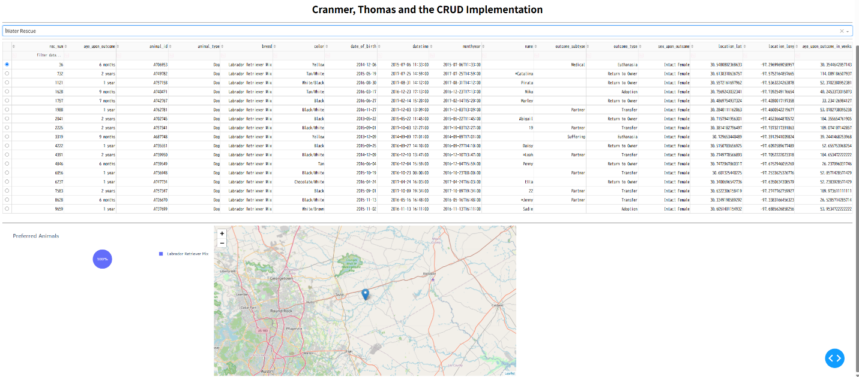
Mountain Rescue: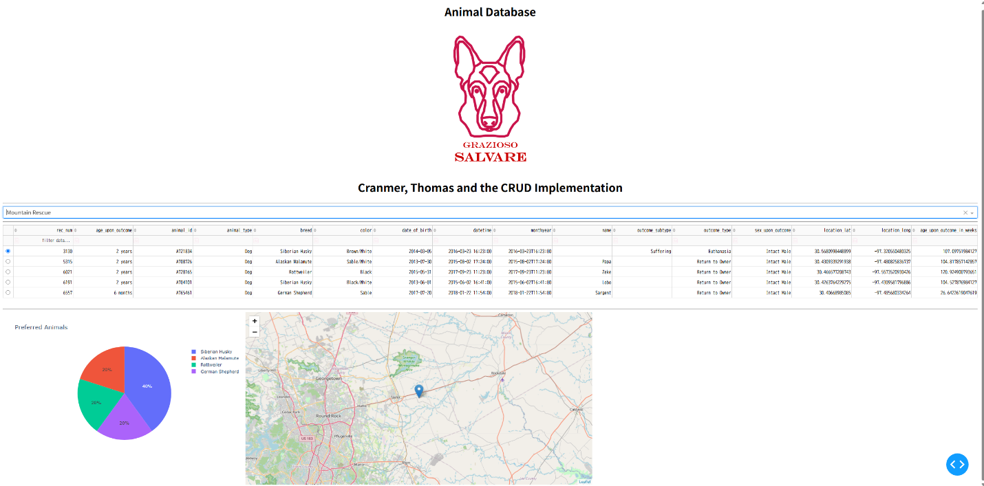
Disaster Rescue: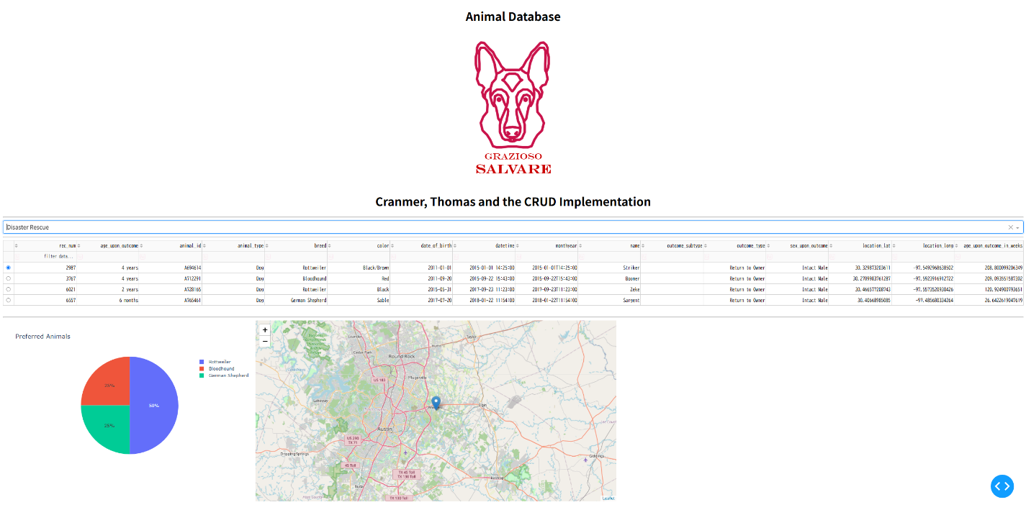
All (Reset): 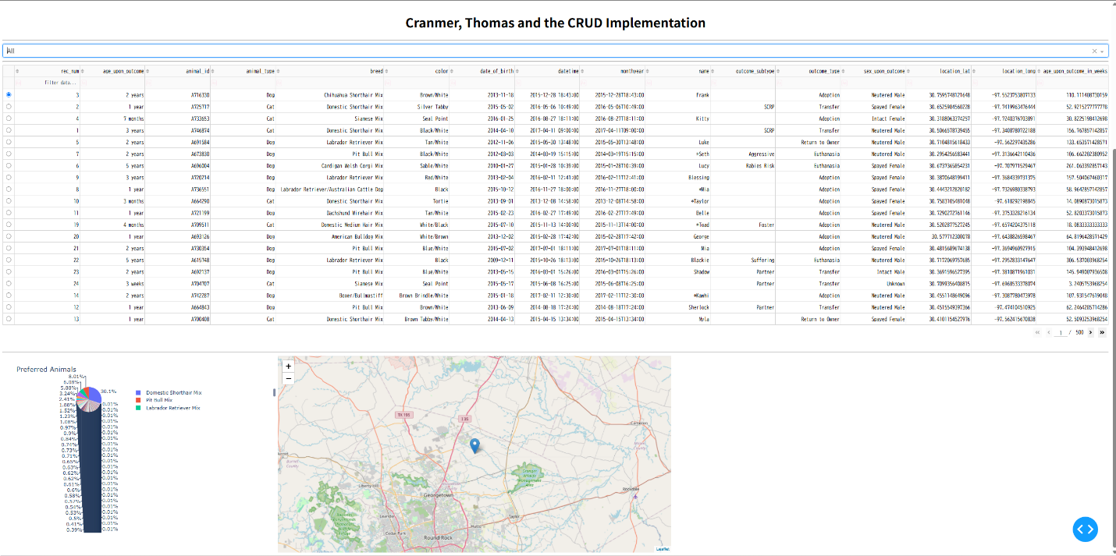

Errors/Challenges:
The big challenge I had was getting the graph to update accordingly, I could get base graph formulation on startup, but any filtering that conducted on the database did that extend to the graphs. TO fix this, I passed the updateGraph method to each instance of filtering and was able to acquire the functionality. 2nd was initial filtering in updateDashboard, any filtering would yield no results on the application, through testing the querying in an independent Jupyter Lab file, and attempting to simply use the query in place of finding all documents, I determined… a variable I used was passed incorrectly and the method’s callback would only work with 1 return rather than 2 (I passed data/column, changing it to just return data fixed the issue).

Contact
Your name: Cranmer, Thomas

